Low Level Design (VIEW REPORTS MODULE)

Project Code | Team1
Project Name | E-Commerce(Online Shopping)

Prepared/Modified by | Role | Date of Preparation
Bhagyashree Vedpathak | Software Engineer | 16/12/2013
Reviewed by | Role | Date of Review
Mrunalee Kothari | Software Engineer | 17/12/2013
Approved by | Role | Date of Approval
Uma M Ponniamman | Training Manager
Circulation List | amit.agarwal@igate.com, mrunalee.kothari@igate.com, keerthi.parthasarathy@igate.com, nidhi.shetty@igate.com, nikeeta.menon@igate.com, shrikant.sutar@igate.com, bhagyashree.vedpathak@igate.com | Version Number of the template:1.0
Version Number | 1.3

Table of Contents

1. Description Of The Unit 3
2. References 4
3. Dependencies / Assumptions 5
4. Class Diagrams 6
5. Sequence Diagrams 7
6. Design Components 8
6.1 List Of UI Components 8
6.2 List Of Design Classes 8
7. Re-Usable Routines/Components 9
8. Messages 10
9. Configuration Files 11
10. Crud Matrix Table 12
11. Data Mapping Matrix 13
12. Action Flow Matrix 14
13. Stored Procedures 15
14. Program Specification / Pseudo Code 16
REVISION HISTORY OF THE WORK PRODUCT 17

Description Of The Unit

The view reports module allows sales manager to view reports of orders placed by customers. The sales manager, when logs in with his/her credentials, will be redirected to this module.
The reports are generated based on following criteria:
- View report by date:
It displays details of all orders placed between the dates entered by sales manager.
- View report by status of orders
It displays details of all orders that are ‘pending’.
- View all orders report
It displays details of all orders placed till date.

References

Reference | Description
Repository reference | https://IGTEBLRSVNTNG.igatecorp.com/svn/oct3_Team1
Class Diagram | /Project Documents/Design Documents/HLD/Class Diagrams
URS | /Project Documents/Requirements/Case Study/Ecommerce-grp1 and grp3.doc
UTP | /Project Documents/Test Plan/UTP/Test Cases/View reports/UTP_ViewReportsModule.xls
DB Design | /Project Documents/Design Documents/HLD/DB Design/E-Commerce_GROUP_DBDESIGN.xls

Dependencies / Assumptions

Dependencies:
Sales Manager should be logged into the system.

Class Diagrams

Class Diagram

Sequence

Sequence Diagram
NA

Design Components

List Of UI Components
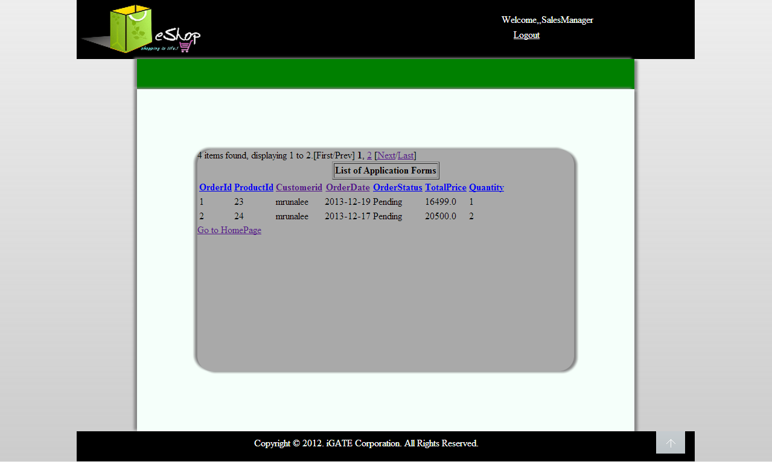

View Records by date:
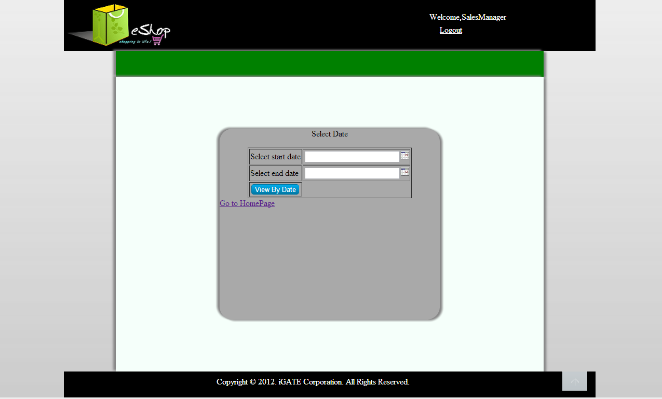

List Of Design Classes

Sr. No. | LLD Name | Class Name | Method Name | Method Description
1 | View Reports | Order (Java Bean) | Appropriate getters and setters methods | Getters retrieve the property values and setters set the property values
2 | View Reports | EshopController | viewReport(@RequestParam(value="radio") String mode, Model model ):String  viewByDateReports(  @RequestParam(value="date1") String date1, @RequestParam(value="month1")String month1,@RequestParam(value="year1") String year1,@RequestParam(value="date2") String date2, @RequestParam(value="month2")String month2,@RequestParam(value="year2") String year2Model model):String | Takes appropriate choice from user and displays corresponding reports.  This method takes dates from user and displays details of all orders between those two dates.
3 | Login Module | EshopBoImpl | getOrderList(int value, Date arrDate): List<Order> | Calls getOrderList(int value, Date arrDate) of EshopDaoImpl class and returns the result to controller.
4 | Login Module | EshopDaoImpl | getOrderList(int value, Date arrDate): List<Order> | Gets details of orders and sends them to EshopBoImpl

Re-Usable Routines/Components

Re-Usable Routines/Components

- CSS files
- Javascript files
- DataAccessException class
- Database properties files
- Logger properties files
- Calendar component

Messages

#. | Type | Message Text
M1 | Error | Please select an option
M2 | Info | There is no order for selected option

Configuration Files

File Name | Path | Description
oracle.properties | /Development/Source | To configure database connection.
Web.xml | /Development/Source | To configure the bean properties.
Dispatcher-servlet.xml | /Development/Source | To configure the request mapping and view resolver.
Eshop_logger.properties | /Development/Source | To configure the logger.
Eshop_error.properties | /Development/Source | To configure error messages.

Crud Matrix Table
# | Table Name | Create | Read | Update | Delete
1 | Order | N | Y | N | N

Data Mapping Matrix

Sr. No. | Screen Label | Field Source | Field Type | Data Type | Max Length | Data Flow | Mandatory
1 | View By Date | NA | Radio Button | NA | NA | UI | NA
2 | View By Status | NA | Radio Button | NA | NA | UI | NA
3 | View All | NA | Radio Button | NA | NA | UI | NA
4 | ViewReports | NA | Button | NA | NA | UI | NA

Legend
D → UI (Database to User Interface)
UI → D (User Interface to Database)
UI (User Interface Only)

Action Flow Matrix

Sr. No. | Action | Description | Process
1 | On click of  ‘View Reports’ Button | Displays reports | Sales Manager can view various reports based on selected radio button. i.e.  1)View by date  2)View by status  3)View all

Stored Procedures

# | Stored Procedure Name  (with Description) | Input/Out Parameters | Type | Size
1. | NA | NA | NA | NA

Program Specification / Pseudo Code

14.1 <ACTION: VIEW_REPORTS_CLICK>

Pseudo Code:
- Client Side Scripting:
IF none of the radio buttons are checked
THEN print M1
IF no order details found
THEN print M2

- Server Side Scripting:
2.1: Display details of orders based on various conditions
BEGIN
Call viewReport(@RequestParam(value="radio") String mode, Model model) in Controller class in presentation layer
BEGIN
Call getOrderList(int value, Date arrDate) in EcommerceBoImpl in service layer
BEGIN
Call getOrderList(int value, Date arrDate) in EcommerceDaoImpl in database layer
BEGIN
Create query for retrieving records from OrderDetails table
Return List of orders
END
Return List of orders to Service Layer
END
Return List of orders to Presentation Layer
END

2.2: Display details of orders between two dates

BEGIN
Call viewByDateReports(@RequestParam(value="date1") String date1, @RequestParam(value="month1")String month1,@RequestParam(value="year1") String year1,@RequestParam(value="date2") String date2, @RequestParam(value="month2")String month2,@RequestParam(value="year2") String year2Model model)
BEGIN
Call getOrderList(int value, Date arrDate) in EcommerceBoImpl in service layer
BEGIN
Call getOrderList(int value, Date arrDate) in EcommerceDaoImpl in database layer
BEGIN
Create query for retrieving records from OrderDetails table
Return List of orders
END
Return List of orders to Service Layer
END
Return List of orders to Presentation Layer
END
REVISION HISTORY OF THE WORK PRODUCT

# | Date | Version # | Section Changed | Details of changes made | Approved By
1 | 16/12/2013 | 1.0 | LLD prepared | NA | Uma M Ponniamman
2 | 17/12/2013 | 1.1 | List of Design Classes,  Configuration files | Name of controller is modified to “EshopControleer”.  More configuration files are added. | Uma M Ponniamman
3 | 18/12/2013 | 1.2 | Reusable components,  References,  Data Mapping Matrix. | Reusable Components added.  File name with relative path is added in the references section.  The name of text boxes(screen label is changed). | Uma M Ponniamman
4 | 24/12/2013 | 1.3 | Configuration files,UI Components | Paths of the configuration files is updated and UI components(Screen Shots) added. | Uma M Ponniamman

